Assignment No 4

Name – Suraj Kumar

PRN - 240840127041

**Assignment 4**

**1. You submitted a job that has finished. You want to see detailed information about the job, such as its resource usage and exit status. How do you do this?**

**2. You need to submit a job that runs on a specific node (e.g., node1). How do you specify the node for the job?**

**3. You want to set a maximum runtime for your job to 3 hours. How do you do this?**

### 1. View Detailed Information About a Finished Job

**Command**: sacct -j <job_id> --format=JobID,JobName,State,AllocCPUs,Elapsed,MaxRSS,ExitCode

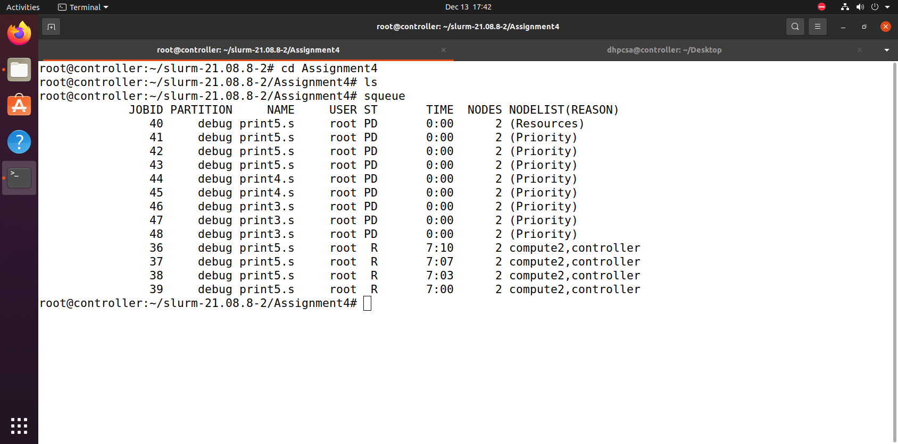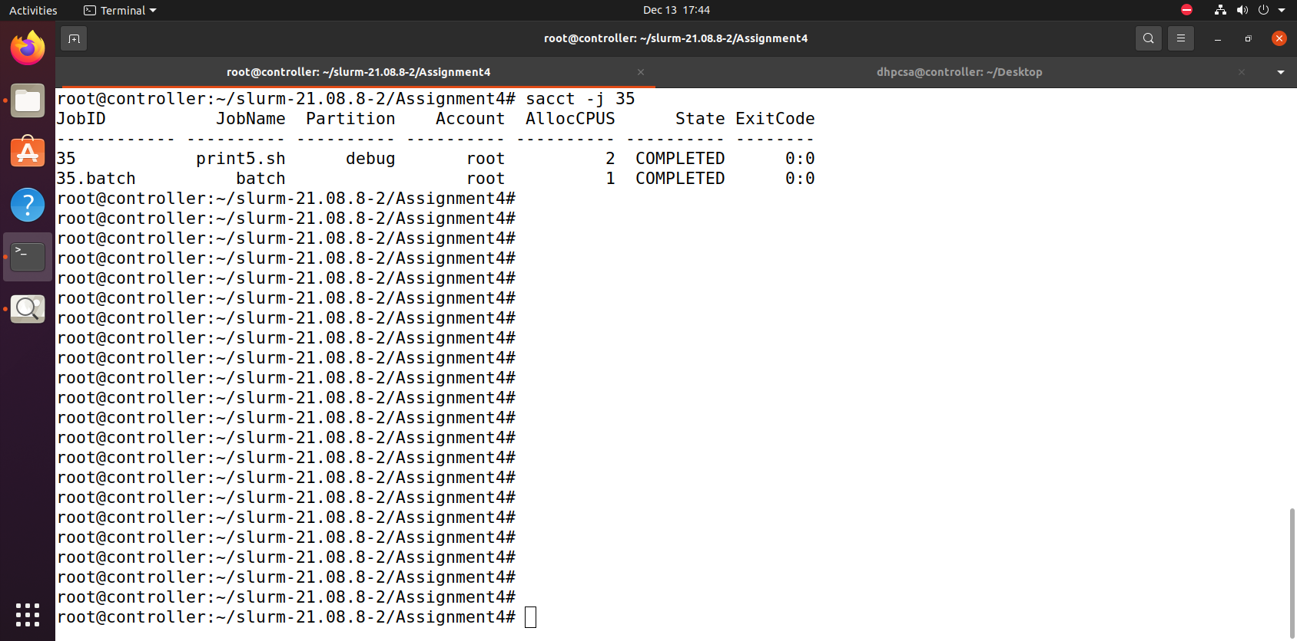

**2. Submit a Job to Run on a Specific Node**

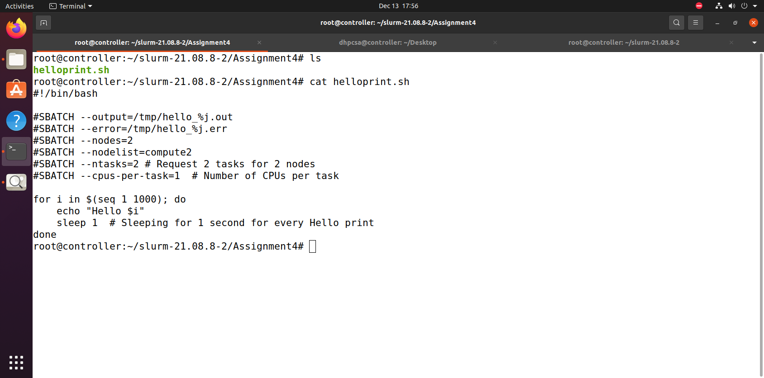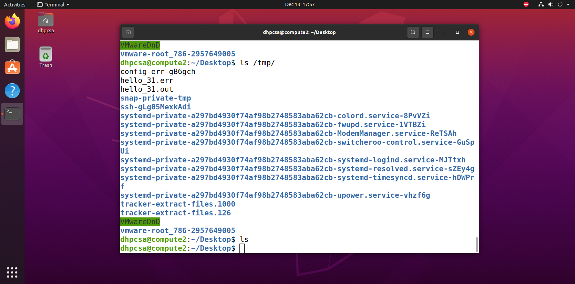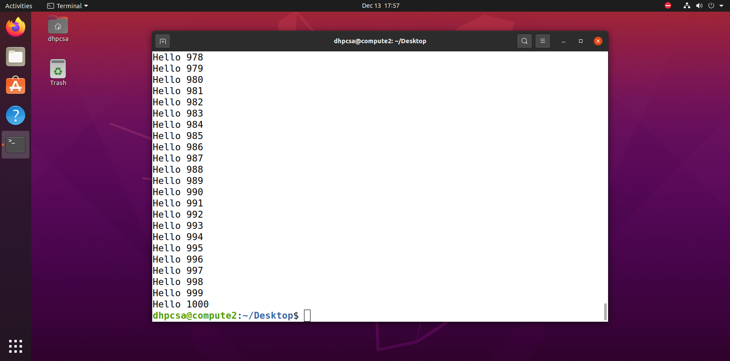

**3. Set a Maximum Runtime for a Job to 3 Hours**

